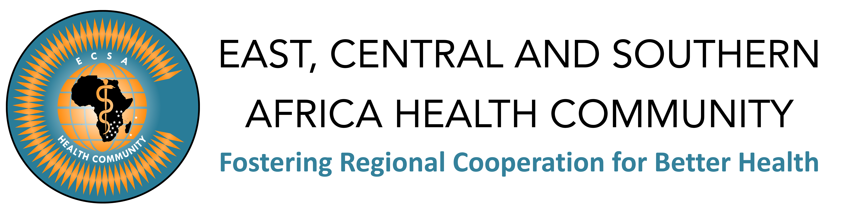

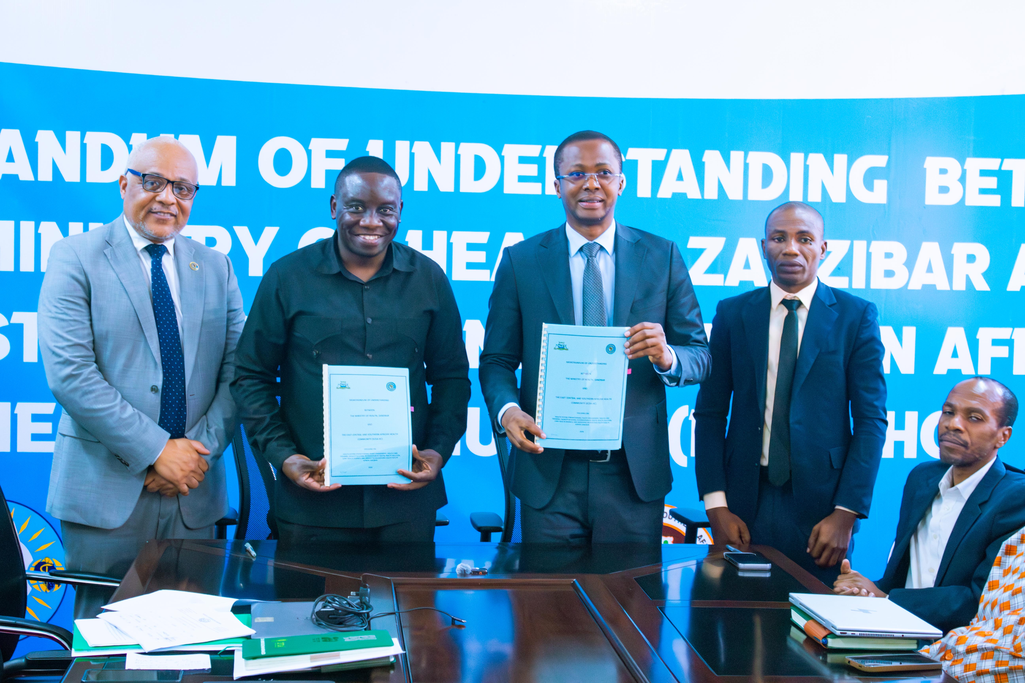

PRESS RELEASE

ECSA-HC and Ministry of Health Zanzibar Sign Landmark MoU to Strengthen Health Systems and Regional Collaboration

Zanzibar, United Republic of Tanzania | 21 April 2026. The East, Central and Southern Africa Health Community (ECSA-HC) and the Ministry of Health Zanzibar today signed a Memorandum of Understanding (MoU), marking a significant milestone in advancing health systems strengthening, innovation, and regional cooperation in the East and Southern Africa region.
The partnership establishes a strategic framework for collaboration aimed at improving healthcare delivery, expanding access to quality services, and strengthening health system resilience in Zanzibar while contributing to broader regional health priorities.
Through this Memorandum of Understanding, ECSA-HC and the Ministry of Health Zanzibar will collaborate across key priority areas, including strengthening health systems and policy engagement, advancing digital health transformation and innovation, enhancing health workforce training and capacity building, promoting joint research and knowledge sharing, improving maternal and newborn health, supporting the prevention and control of communicable and non-communicable diseases, and reinforcing emergency preparedness and health security.
The Principal Secretary, Ministry of Health Zanzibar, Dr. Mngereza Mzee Miraji, commended the partnership, noting:
“This MoU will pave the way for Zanzibar to benefit from ECSA-HC’s regional health colleges, providing our healthcare professionals with opportunities for specialized training and professional development. It also opens avenues for Zanzibar to utilize regional centres of excellence, strengthening our capacity to deliver high-quality healthcare services.”
He further emphasized the significance of the collaboration, adding:
“This partnership marks an important step in strengthening Zanzibar’s health system. By working closely with ECSA-HC, we are creating new opportunities to enhance service delivery, build capacity among our health workforce, and adopt innovative solutions that will improve health outcomes for our people.”

The agreement also places strong emphasis on leveraging digital health and artificial intelligence, enhancing regional specialist training programmes, and exploring medical tourism opportunities to position Zanzibar as a hub for high-quality healthcare services.
Speaking during the signing ceremony, ECSA-HC Director General, Dr. Ntuli Kapologwe, highlighted the importance of the partnership:
“This MoU represents a critical step in strengthening collaboration between ECSA-HC and Zanzibar. It reinforces our commitment to supporting Member States in building resilient, equitable, and innovative health systems that respond to the needs of our populations.”
The Ministry of Health Zanzibar reaffirmed its commitment to strengthening healthcare delivery through partnerships that drive innovation, improve service quality, and enhance access to care for all citizens.
This collaboration will be implemented through joint structures, including a Joint Steering Committee and technical working teams, ensuring coordinated action, accountability, and measurable impact.
The partnership reflects a shared vision to accelerate progress towards Universal Health Coverage (UHC), improve health outcomes, and promote sustainable, people-centred health systems across Zanzibar and the wider ECSA region.
Dr. Ntuli Kapologwe also used the occasion to highlight an upcoming major regional scientific conference—the East, Central and Southern Africa College of Nursing and Midwifery (ECSACONM)—which will be hosted in Zanzibar. He formally requested the Principal Secretary to extend an official invitation to the President of Zanzibar, Hussein Ali Mwinyi, to grace the event.
The 17th ECSACONM Biennial Scientific Conference and 8th Quadrennial General Assembly will take place from 14th to 18th September 2026 in Zanzibar, bringing together nursing and midwifery professionals, policymakers, and partners from across Africa and beyond.
“The upcoming sessions on 15th and 16th will bring together a diverse community of nurses, midwives, researchers, policymakers, trainers, practitioners, and health partners—creating a vital platform for shared learning and collaboration.
We are particularly proud of the ECSACONM Fellows Graduation Ceremony on 14th September, which will celebrate eleven outstanding graduates during the official opening—marking a significant milestone in strengthening our regional health workforce.
Furthermore, the 8th Quadrennial Meeting on 17th and 18th will provide an important opportunity for Member States and partners to engage, reflect, and shape the future direction of ECSACONM, with the agenda to be shared in due course,” added Dr. Ntuli Kapologwe.

About ECSA-HC
The East, Central and Southern Africa Health Community (ECSA-HC) is an intergovernmental organization that fosters regional cooperation in health among its Member States: Eswatini, Kenya, Lesotho, Malawi, Mauritius, Tanzania, Uganda, Zambia, and Zimbabwe. It works to strengthen health systems, promote policy harmonization, and support capacity development across the region.

Media Contact

Mr. Owen Mwandumbya
Communications & Advocacy Specialist
East, Central and Southern Africa Health Community (ECSA-HC)
P.O. Box 1009, Plot No. 157, Olorien, Njiro Road, Arusha Tanzania
Telephone: +255-27-2973677/8
Mobile: +255 (0) 763 820 604
Email: omwandumbya@ecsahc.org

